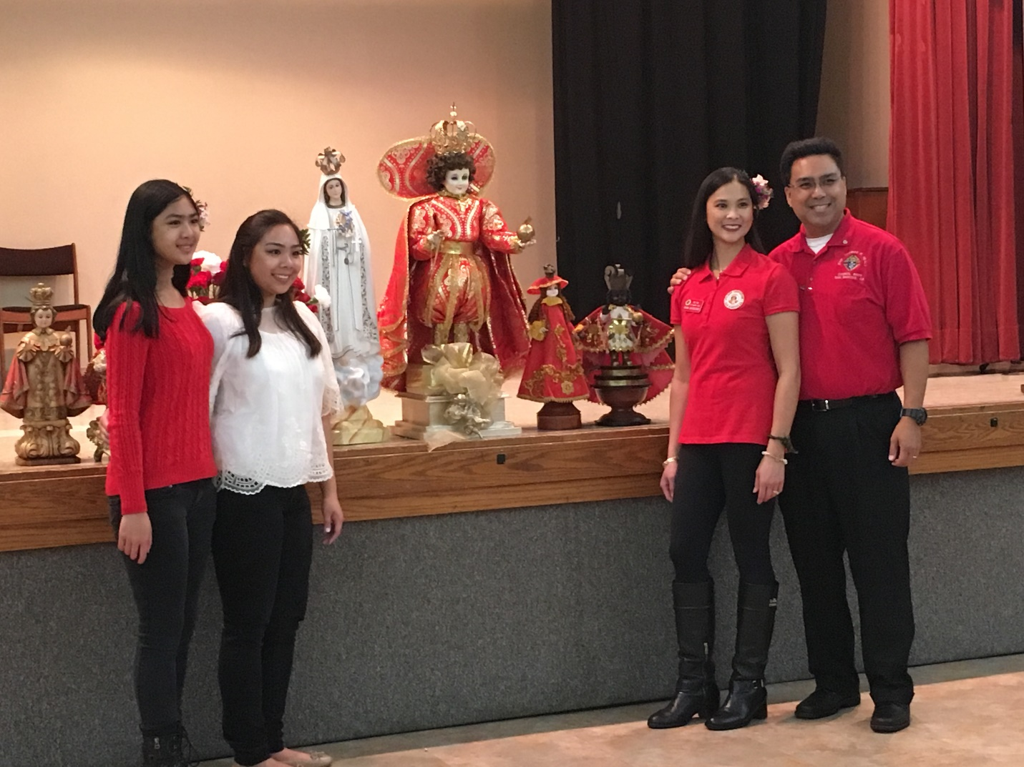SK Joel Avendano his wife Anna and two daughters Jordan and Kyla.

Our Family of the month for January is the Avendanos from St. Marks Parish in San Marcos. Brother Joel is the Grand Knight for Monsignor Thomas P. Healy Council 6979 and the Faithful Purser for the Father Peyri Assembly. He and his family are members of the Santo Nino group at St Mark's. The annual fiesta celebrates the feast day of the Holy Infant Jesus, Santo Niño, and they all worked hard to ensure it was a great event. Joel and Anna are Eucharistic Ministers and his daughters are altar servers. The youngest also plays music for the choir. His wife and daughters also work with the children of the parish and prepare the young girls for hula performances during some events. They are also active in the helping run the St. Mark’s annual Festa, which Joel headed up this year as Chairman. The Avendano family shows their dedication to the Council and the parish through their many activities and volunteerism, all which make them deserving of being named our San Diego Diocese Chapter Family of the Month.

