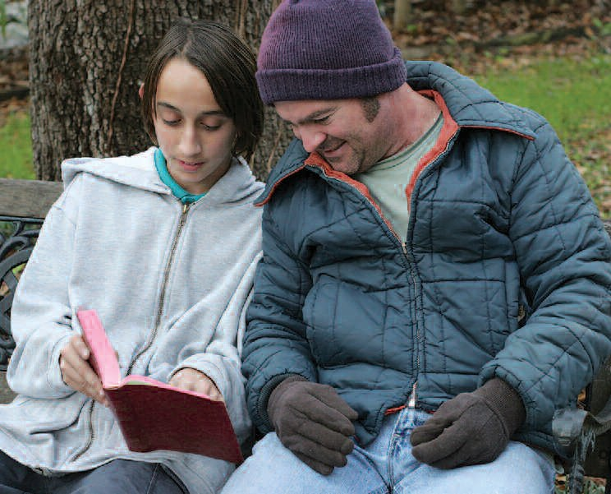
June

Because the family is the subject of the New Evangelization, we want to share our faith with other families.

For Families

For Meditations on this month’s theme see page 41
Every Catholic is called to holiness, and every Catholic is called to reflect this holiness in his or her state of life, whether as a priest
or religious, a husband or wife, a father or mother, or an employer, employee, consumer, neighbor, parishioner or citizen.

As the saints have shown so well throughout history, holiness in life leads inevitably to witness in our daily lives. This witness is the primary way to evangelize in our time.

It is through living our lives as Catholic families, devoted to our faith, to each other and to helping those in need, that we best evangelize in a world that often seems reluctant to hear this good news.

Family Project

Prepare a bowl at home with cards with ideas for small sacrifices/offerings written on them. Every day, each member of the

family takes one of the cards and presents the offering for a relative or a friend in need. At the end of the month, each family member will write a letter (or email) to the person they made the offering for, telling him or her that for the month they were remembered and that the family offered its sacrifices for him or her.

Bring Song Into Your Home Laudate Omnes Gentes (Taize chant) Laudate omnes gentes, laudate Dominum. Laudate omnes gentes, laudate Dominum.
(Sing praise, all you people, sing praise to the Lord.)

Psalm of the Month (Psalm 148)
Pray the Psalm of the Month during every Sunday of the month at your family prayer space.

Praise the Lord from the heavens, praise him in the heights!
Praise him, all his angels, praise him, all his host! Praise him, sun and moon,
praise him, all you shining stars! Praise him, you highest heavens, and you waters above the heavens!
Let them praise the name of the Lord!
For he commanded and they were created. And he established them for ever and ever;
he fixed their bounds which cannot be passed. Praise the Lord from the earth,
you sea monsters and all deeps, fire and hail, snow and frost,
28
stormy wind fulfilling his command! Mountains and all hills,
fruit trees and all cedars! Beasts and all cattle,
creeping things and flying birds! Kings of the earth and all peoples, princes and all rulers of the earth! Young men and maidens together, old men and children!
Let them praise the name of the Lord, for his name alone is exalted;
his glory is above earth and heaven. He has raised up a horn for his people, praise for all his saints,
for the people of Israel who are near to him. Praise the Lord!

On the last Sunday of the month, discuss as a family which verse stood out most for each member.

Movie Night
“Despicable Me”
June
Before the movie begins, ask your families to share their letters on the offerings/sacrifices given in remembrance of a relative or person in need.
Council– Wide Event

Volunteering Together Project – Garden for Those in Need

Hunger knows no season, and there are families in need throughout the year. One way to help these families in need and promote fellowship among your council and parish families is to start a K of C family garden to raise fresh vegetables to donate to food pantries and soup kitchens to help people in need. Find a sizable plot of land that you can utilize for the field, till the soil and put in some basic crops such as potatoes, squash, tomatoes, etc. Set up a daily schedule for families to come in and weed and water the garden. Once the crops are ready, get all your volunteers together to harvest, package and deliver the produce.

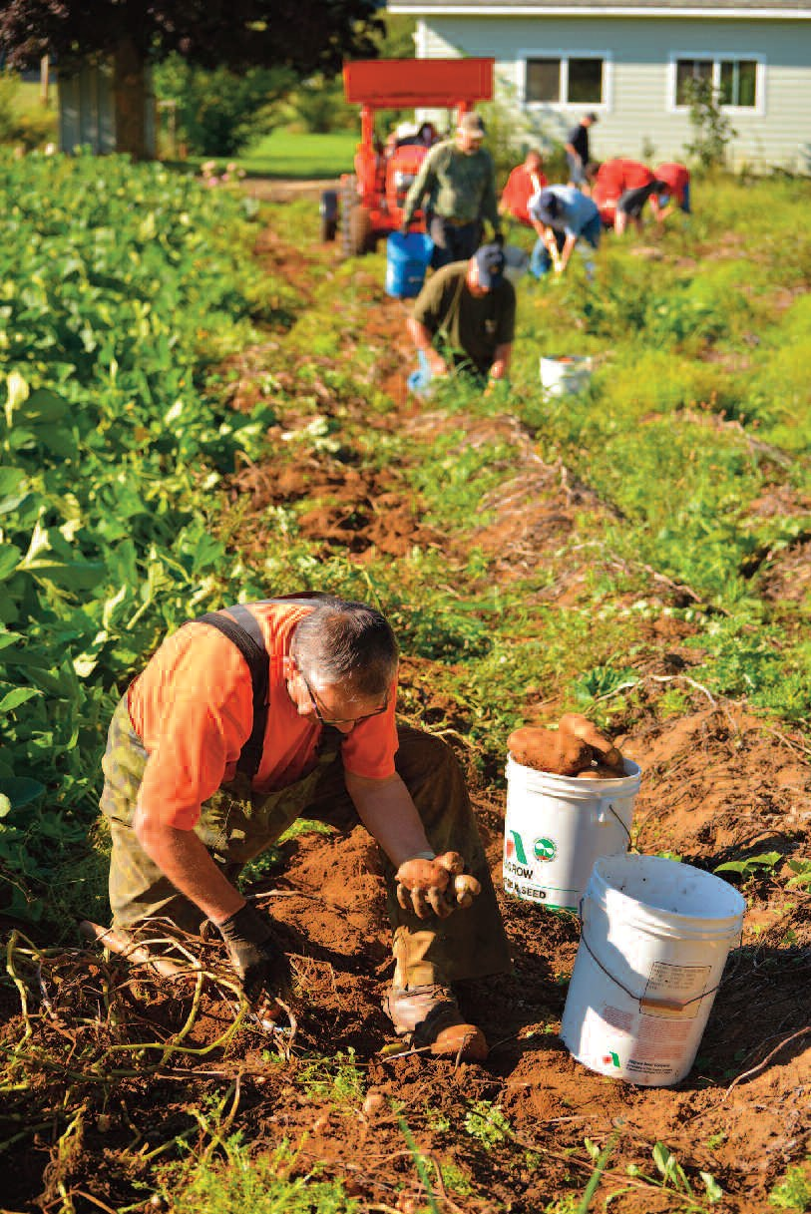
For councils in more urban settings, consider having each member and his family set up a smaller garden
— or even a pot with some tomato or similar vegetable plants — at home, and donate the combined produce of these mini-gardens.

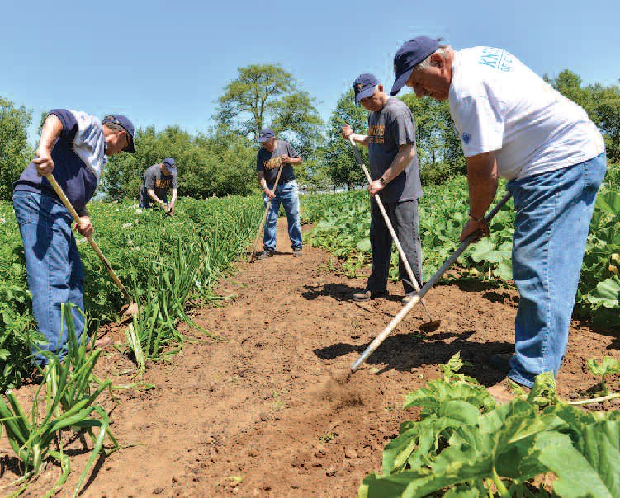
Otherwise, your council can hold an ongoing summertime food drive to help those in need.

29

