April

Because our children may be called to become spouses and parents, we want to help them to explore the vocation to marriage and family life.

For Families
For Meditations on this month’s theme see pages 39-40
Understanding the nature of self-giving love that we are called to in all our relationships can be difficult, especially for teenagers and
young adults just coming to terms with this part of their lives.

Romantic love — such as a teen’s first crush — shows love in an emotional stage. It can be fleeting and fickle, but it can also evolve into the more important element of love in friendship. In this latter stage, each person wants the best for the other and for themselves in the hope of becoming unified. With this should come the understanding of just how important abstinence is for relationships outside of marriage. The move from “I” to “we” in a relationship is often the final step to betrothed love or marriage. This self- surrender and personal commitment is the basis for married love and the start of the family.

Helping others to navigate and come to understand these deep emotions can be one of the greatest challenges and rewards a family can face.

Family Project

Plan a special meal together and speak about your first date with your children.

- Tell them about what first made you notice each other.
- Describe where you went on your first date.
- Talk about how this initial attraction grew into a deeper friendship and then authentic love.

Next, tell your children about your marriage, the ceremony, making the adjustment from being single to being a couple, having children and the changes that it brought, and how you dealt with hard times and celebrated good times. Afterward, look through old photos and put together a slideshow tracing your relationship from when you first met to today.

Bring Song Into Your Home Regina Caeli
Regina caeli, laetare, alleluia.
Quia quem meruisti portare, alleluia.
Resurrexit sicut dixit, alleluia. Ora pro nobis Deum, alleluia.
(Queen of Heaven, rejoice, alleluia.
For He whom you did merit to bear, alleluia.
Has risen as he said, alleluia. Pray for us to God, alleluia.)
Use during Easter time. Return to “Jesus, Remember Me” during Lent.

Psalm of the Month (Psalm 16)
Pray the Psalm of the Month during every Sunday of the month at your family prayer space.

Preserve me, O God, for in thee I take refuge. I say to the Lord, “Thou art my Lord;
I have no good apart from thee.”
As for the saints in the land, they are the noble, in whom is all my delight.
Those who choose another god multiply their sorrows;
their libations of blood I will not pour out or take their names upon my lips.
The Lord is my chosen portion and my cup; thou holdest my lot.
The lines have fallen for me in pleasant places; yea, I have a goodly heritage.
I bless the Lord who gives me counsel;
in the night also my heart instructs me. I keep the Lord always before me;
because he is at my right hand, I shall not be moved.
Therefore my heart is glad, and my soul rejoices; my body also dwells secure.
For thou dost not give me up to Sheol, or let thy godly one see the pit.
Thou dost show me the path of life; in thy presence there is fulness of joy,
in thy right hand are pleasures for evermore.

On the last Sunday of the month, discuss as a family which verse stood out most for each member.

20

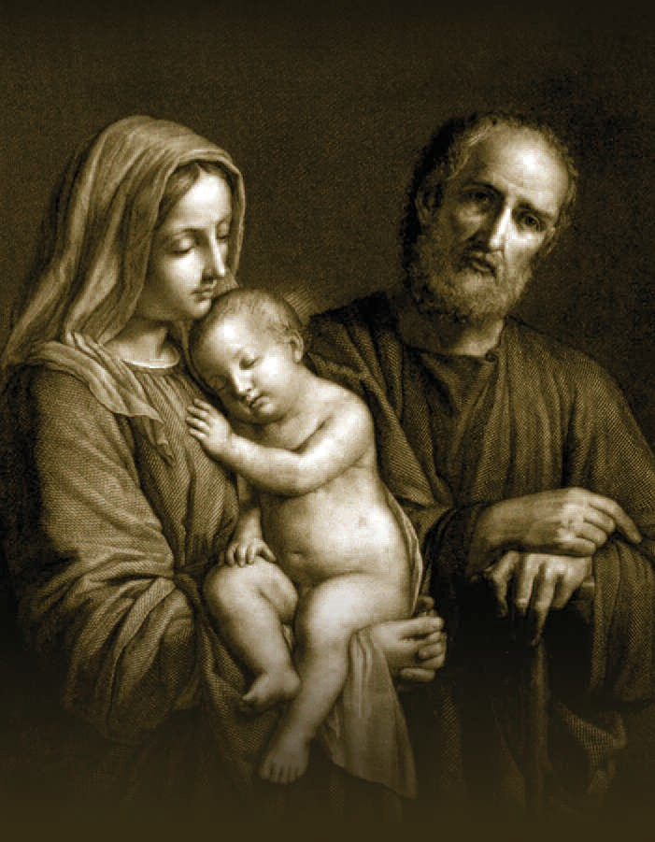

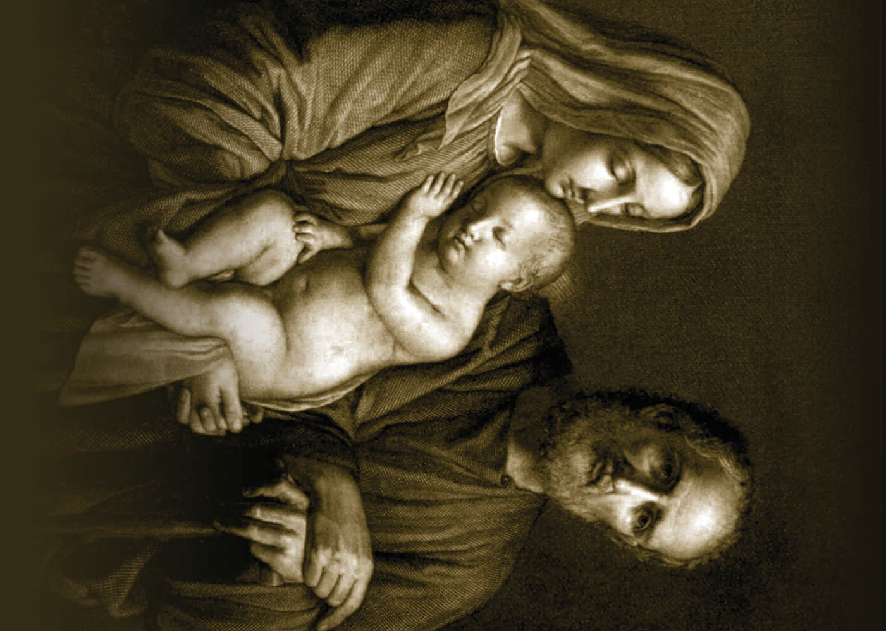

A F A M I LY PR AY E R
H family. Enlighten our hearts and minds that
we may live more fully this vocation to love.
In our daily life and work,
may we reflect the self-giving love which you,
O Father, eternally show with your Son and the Holy Spirit.
Let your love be evident in the peace that reigns in our home and in the faith we profess and live. May our family always be a place of generosity, understanding, forgiveness and joy.
Kindly give us the wisdom and courage to be witnesses to your eternal design for the family; and grant that the Holy Family
of Nazareth may always guide our path to holiness as a family.
We ask this through our Lord Jesus Christ, your Son, who lives and reigns with you in the
unity of the Holy Spirit, one God forever and ever.
Amen.
eavenly Father, thank you for the gift of our
Prayer composed by Archbishop William E. Lori of Baltimore, Supreme Chaplain.
The cover image of the Holy Family is a drawing by Giovanni Balestra, based on a painting by Sassoferrato. The original print is housed at the Pontifical John Paul II Institute for Studies on Marriage and Family in Rome. Used with permission.
10086 1-14
A FA M I LY P R AY E R
H family. Enlighten our hearts and minds that
we may live more fully this vocation to love.
In our daily life and work,
may we reflect the self-giving love which you,
O Father, eternally show with your Son and the Holy Spirit.
Let your love be evident in the peace that reigns in our home and in the faith we profess and live. May our family always be a place of generosity, understanding, forgiveness and joy.
Kindly give us the wisdom and courage to be witnesses to your eternal design for the family; and grant that the Holy Family
of Nazareth may always guide our path to holiness as a family.
We ask this through our Lord Jesus Christ, your Son, who lives and reigns with you in the
unity of the Holy Spirit, one God forever and ever.
Amen.
eavenly Father, thank you for the gift of our
Prayer composed by Archbishop William E. Lori of Baltimore, Supreme Chaplain.
The cover image of the Holy Family is a drawing by Giovanni Balestra, based on a painting by Sassoferrato. The original print is housed at the Pontifical John Paul II Institute for Studies on Marriage and Family in Rome. Used with permission.
10086 1-14

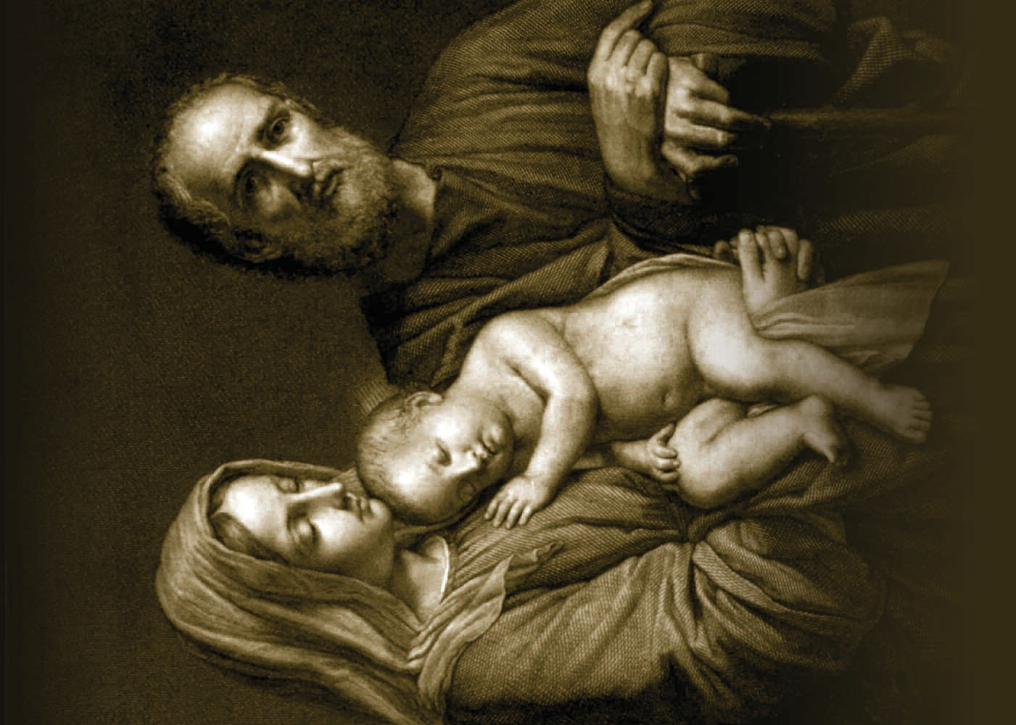

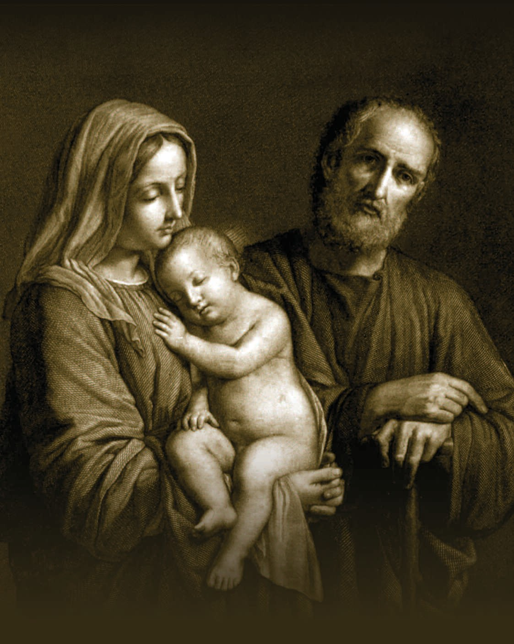

Council– Wide Event for April

Volunteering Together Project – Renewal of Marriage Vows
April
Movie Night “Beauty and the Beast”
Before the movie begins, ask your families to share their slideshows tracing the parents’ courtship and marriage.

Families are the base on which the Knights of Columbus rests, and the vow of marriage exchanged between a man and a woman in love is the foundation for each family. In light of this, consider holding a marriage vow renewal ceremony to offer couples a chance to remind themselves of their sacred commitment to each other and their place in God's plan.

Ask your council chaplain to help plan a marriage vow renewal program for your council or perhaps the entire parish. It can take the form of a Mass or prayer service that offers married couples a chance to renew their vows. Councils and assemblies might also consider sponsoring an annual or semiannual spiritual retreat for married couples.

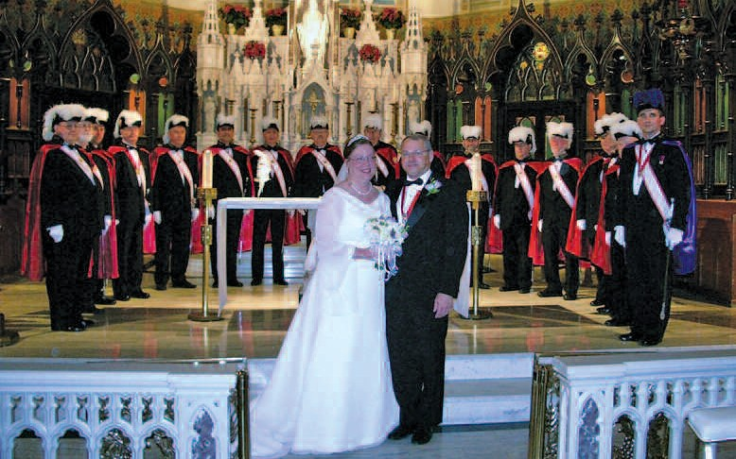
The Supreme Council Supply Department offers “A Covenant Renewed” certificate (#2745) to couples renewing their marriage vows. This certificate, suitable for framing, makes a nice commemorative gift and is available for 25 cents from the Supply Department.
25

