**Come As you Are**

**& Praise Him!**

**Diocesan Revival**

***Reverend Anthony Bozeman*** *was raised in Philadelphia within the parish boundaries of Our Mother of Sorrows. Fr. Bozeman began his formal education at Our Mother of Sorrows, and then continued on to West Philadelphia Catholic High School. Upon graduation from West Catholic, Fr. Bozeman pursued his undergraduate studies at LaSalle University in Philadelphia. Fr. Anthony joined the U.S. Military, serving his country for 16 years of combined Active and Air National Guard Reserve duty. Fr. Bozeman entered St. Charles Borromeo Seminary in Philadelphia and was ordained to the priesthood on May 20, 2000. Fr. Bozeman served as Parochial Vicar at Our Lady of Grace and Our Lady of Hope Churches. Fr. Bozeman was assigned as parochial vicar of Our Mother of Mercy and Our Lady Star of the Sea Parishes in Houston, Texas. The Josephites on August 1, 2006 assigned Fr. Bozeman as pastor of St. Joan of Arch Church in New Orleans, LA. Archbishop Hughes of New Orleans in October of 2006 appointed Fr. Bozeman chaplain of Xavier Prep High School. July 12, 2008 Fr. Bozeman was assigned as pastor of St. Raymond & St. Leo the Great Parish*

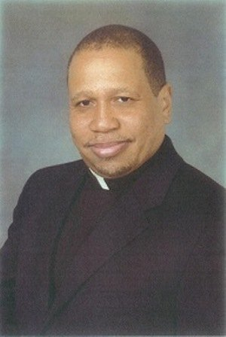

Featuring Catholic Gospel Choirs:

**St Rita’s Gospel Choir**

**The Christ the King Sanctuary Choir**

**The Christ the King Youth Choir**

**St. Rita’s Catholic Church**

**5124 Churchward St., San Diego, Ca 92114**

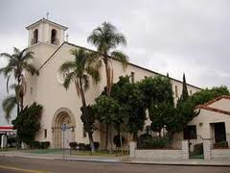

Reverend Anthony Michael Bozeman, S.S.J.

**3 Nights Only!**

**Beginning at 7PM**

Monday February 2nd, Tuesday February 3rd **&** **Youth Night**

**Wednesday February 4th**

**[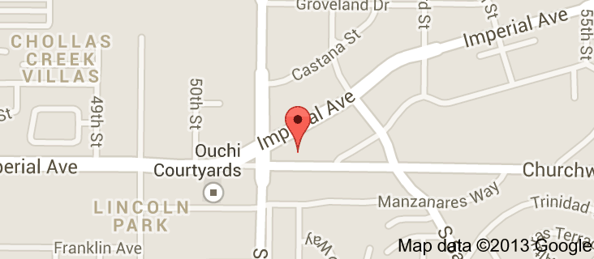](http://maps.google.com/maps?bav=on.2,or.r_qf.&bvm=bv.53760139,d.cGE,pv.xjs.s.en_US.63KCSWWF6Aw.O&biw=1152&bih=616&dpr=1&um=1&ie=UTF-8&q=St+Rita's+Catholic+Church&fb=1&gl=us&hq=st+rita+san+diego&cid=0,0,17945461482518301959&sa=X&ei=pb1UUpGsA-OZiQKev4CwBg&ved=0CKwBEPwSMAs)**