May

Because in the beginning of creation God gave the commandments of work, we want to harmonize work and family life.

For Families

For Meditations on this month’s theme see page 40
Through work, parents help to meet their needs and the needs of their children. They fulfill their roles as guardians and providers.
While the need to work does take away from time spent as a family, it also offers the opportunity for parents to set an example of commitment to support the family and of working together with others to get a job accomplished.

Children can also learn from work through the simple responsibilities of performing chores — feeding the pets, taking out the garbage, washing dishes, etc. They learn they are responsible for their own actions, how to be a part of a team and the satisfaction that comes with labor well done.

Bring Song Into Your Home Immaculate Mary
Immaculate Mary, your praises we sing.

You reign now in Heaven, with Jesus our King.

Ave, Ave, Ave Maria. Ave, Ave, Ave Maria. In Heaven the blessed your glory proclaim;
On Earth we your children invoke your sweet name.

Ave, Ave, Ave Maria. Ave, Ave, Ave Maria.

Family Project

Develop teamwork among your family members by working together to complete a project in your parish or community.

Create a garden for Mary or a special statue location, visit local cemeteries in spring to assist with a clean up, or schedule a time to pray the rosary together as a family.

Psalm of the Month (Psalm 127)
Pray the Psalm of the Month during every Sunday of the month at your family prayer space.

Unless the Lord builds the house, those who build it labor in vain. Unless the Lord watches over the city, the watchman stays awake in vain.
It is in vain that you rise up early and go late to rest, eating the bread of anxious toil;
for he gives to his beloved sleep.
Lo, sons are a heritage from the Lord, the fruit of the womb a reward.
Like arrows in the hand of a warrior
26
are the sons of one’s youth. Happy is the man who has his quiver full of them!
He shall not be put to shame
when he speaks with his enemies in the gate.

On the last Sunday of the month, discuss as a family which verse stood out most for each member.

Movie Night
“Monsters Inc.”
May
Before the movie begins, ask your families to share the photos of their garden and the experiences of working on it.
Council– Wide Event

Volunteering Together Project – Parish Spring Cleaning

Just as individuals form a family, families form a parish. Support your council’s parish family by organizing your families and interested parish families to help clean up your parish. Contact your pastor and ask what needs to be done in the way of:

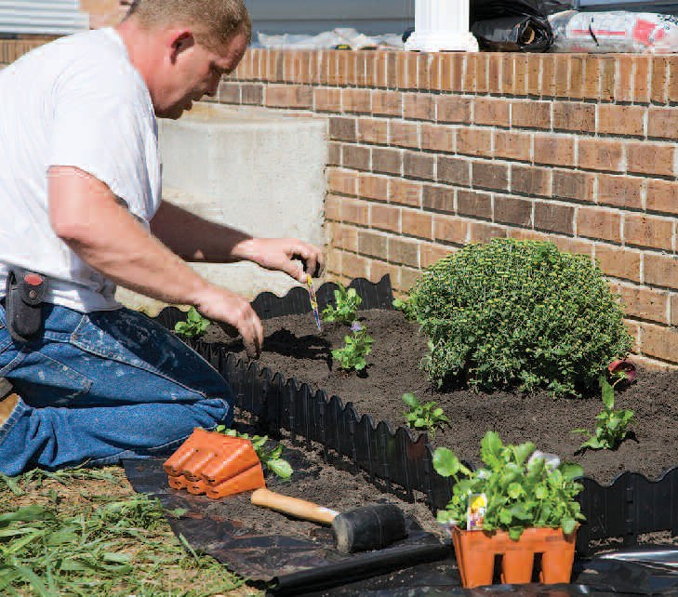
- Sweeping out the church, parish hall and office
- Painting interior walls
- Simple roof repairs
- Landscaping and planting
- Painting exterior walls
- Other minor repairs

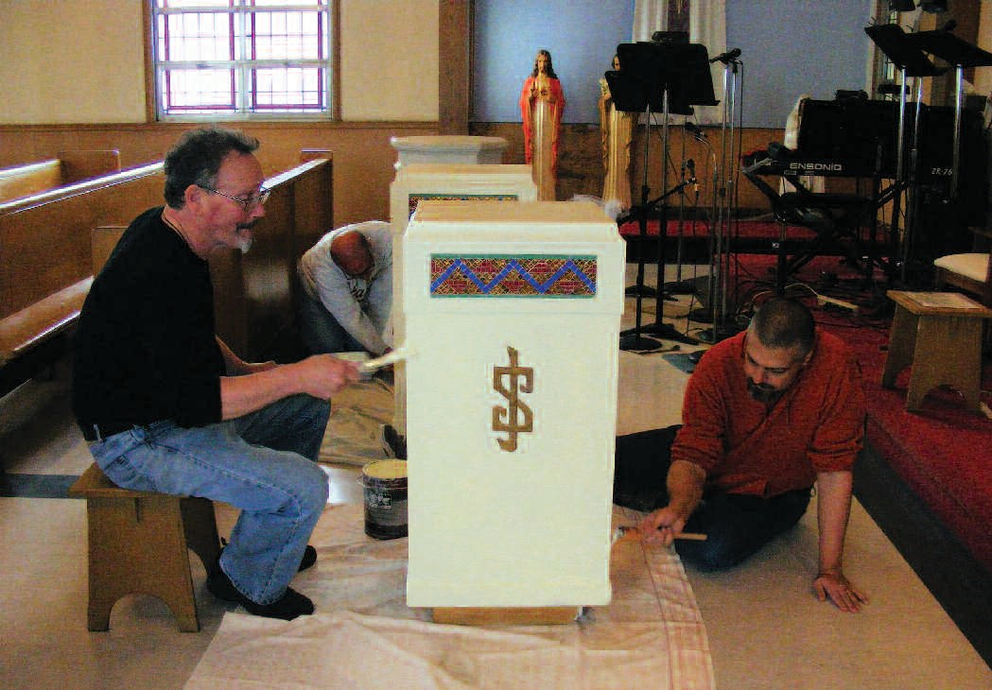
After the work is done, gather everyone together for a cookout or potluck dinner.

