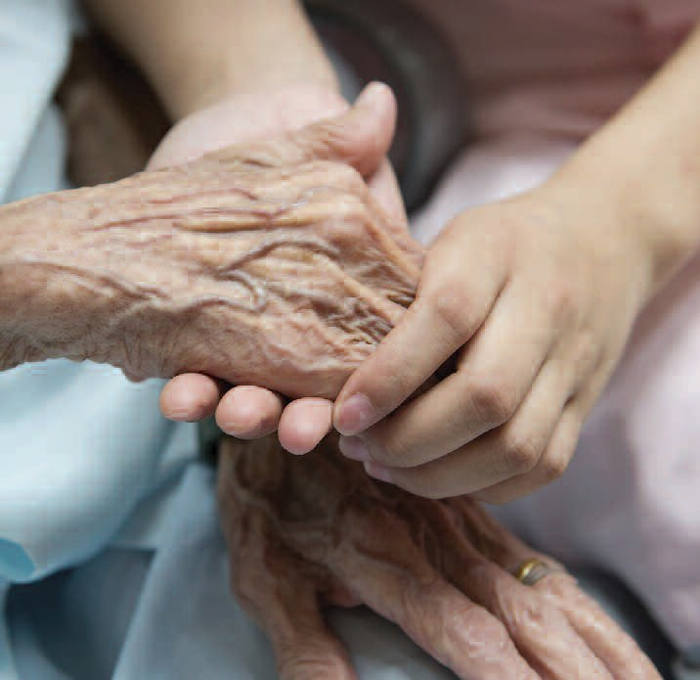
July

Because God is the Father of orphans and widows, we want to reach out to all those who are lonely and abandoned.

For Families

For Meditations on this month’s theme see page 41
God takes care of us; he is our guardian. In a special way, he is the “Father of orphans and Defender of widows” (Ps 68). In the
ancient world, orphans and widows were the weakest elements of society. Without parents or a husband taking care of them, they were defenseless.

God takes care of us by sending us Jesus Christ, his only Son. Like the Good Samaritan, Jesus was especially close to the sick, hungry, lonely and poor. In this way, he gives us the answer to Cain’s question: “Am I my brother’s keeper?” (Gen 4:9). Every man is his “brother’s keeper.” God has entrusted us to one another.

Family Project

Like the Good Samaritan, we are called to live out the Corporal Works of Mercy: feed the hungry, give drink to the thirsty, clothe the naked, shelter the homeless, visit the sick and the imprisoned, and bury the dead.

Offer your time, talent and money to help the poor, the lonely and those in need.

Think about a person, family, relative, friend or neighbor who may be alone, needy or new to the parish or school. Invite them to your home for dinner.

Bring Song Into Your Home Ubi Caritas (Taize chant)
Ubi caritas et amor, Ubi caritas, Deus ibi est.

(Where there are charity and love, God is there.)

Reading of the Month (Isaiah 58)
Share this Reading of the Month during every Sunday of the month at your family prayer space.

Is such the fast that I choose,
a day for a man to humble himself?
Is it to bow down his head like a rush,
and to spread sackcloth and ashes under him? Will you call this a fast,
and a day acceptable to the Lord? Is not this the fast that I choose: to loose the bonds of wickedness, to undo the thongs of the yoke, to let the oppressed go free,
and to break every yoke?
Is it not to share your bread with the hungry,
30
and bring the homeless poor into your house; when you see the naked, to cover him,
and not to hide yourself from your own flesh? Then shall your light break forth like the dawn, and your healing shall spring up speedily;
your righteousness shall go before you,
the glory of the Lord shall be your rear guard. Then you shall call, and the Lord will answer; you shall cry, and he will say, Here I am.

On the last Sunday of the month, discuss as a family which verse stood out most for each member.

Movie Night
“Jungle Book”
July
Before the movie begins, ask your families to share their experience with sharing a meal with someone who is lonely or in need.
Council– Wide Event

Volunteering Together Project – Habitat for Humanity

Knights at the local level donate millions of hours of volunteer service and millions of dollars to assist Habitat for Humanity in helping to build or renovate houses for families in need.

Habitat for Humanity is a nonprofit Christian organization founded in 1976 that seeks to eliminate poverty housing and homelessness one family at a time. The organization assists in providing quality- built, affordable homes to needy families by cooperatively involving the future homeowner with community volunteers and suppliers to build or renovate the home. In addition to a down payment, recipients work alongside the construction crew and volunteers, and are then provided an affordable mortgage plan.

Knights look favorably on the mission of Habitat for Humanity, which not only helps people to become homeowners, but actively involves them in the house’s preparation. This teaches them valuable skills, develops confidence and provides experience.

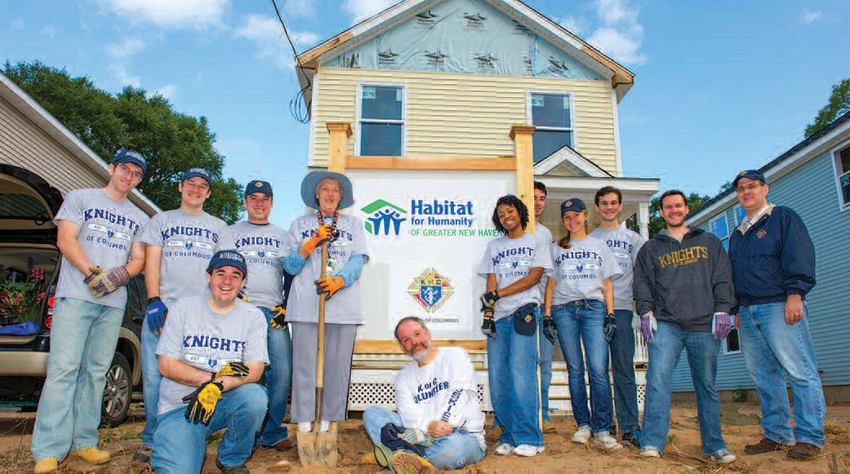
Contact your local Habitat branch and arrange a day for your council families to volunteer and help someone receive the gift of shelter.

31

