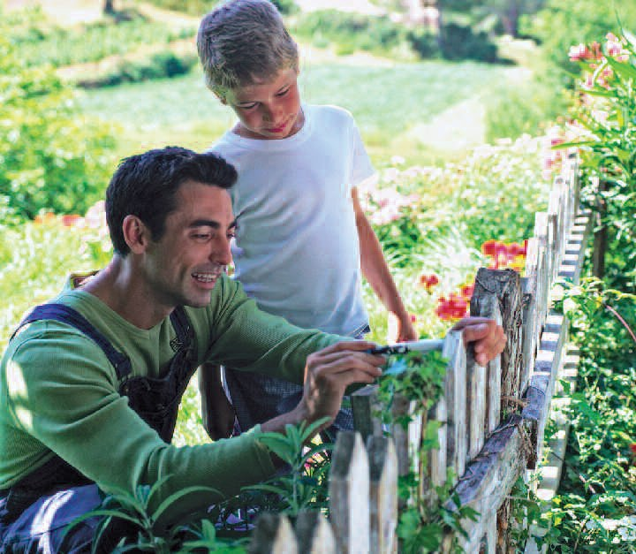
March

Because the joy of all parents is to teach their children the art of living, as parents we want to be the primary educators of our children.

For Families

For Meditations on this month’s theme see pages 39
To educate is to teach the very art of life, the art of humanity. It is a new birth not simply to life, but to the personal life. A child is called
to something greater than himself or herself and will realize this through his or her relationship with others. To educate means to help a child to become a good son or daughter, a good brother or sister, a good friend and student until he or she becomes a good husband or

Psalm of the Month (Psalm 78)

Pray the Psalm of the Month during every Sunday of the month at your family prayer space.

Give ear, O my people, to my teaching; incline your ears to the words of my mouth! I will open my mouth in a parable;
things that we have heard and known, that our fathers have told us.
We will not hide them from their children, but tell to the coming generation
the glorious deeds of the Lord, and his might, and the wonders which he has wrought.
He established a testimony in Jacob, and appointed a law in Israel, which he commanded our fathers to teach to their children;
that the next generation might know them, the children yet unborn,
and arise and tell them to their children, so that they should set their hope in God, and not forget the works of God,
but keep his commandments.
On the last Sunday of the month, discuss as a family which verse stood out most for each member.
18

wife and a good father or mother, or a good priest or religious sister.

Parents are the primary educators of their children. We — the whole of society, the school, the parish and other families — are called to collaborate in this great mission.

“What will this child be? For surely the hand of the Lord is with him” (Lk 1:66). In Nazareth, Jesus grew and advanced “in wisdom, age and favor before God and man” (Lk 2:52).

Family Project

Invite the families of your children’s friends to join you in a pilgrimage to a religious site. A pilgrimage is a journey a person or a group makes to a sacred place for the purpose of venerating it or to ask for heavenly aid, and to ultimately come to know God better. During the journey to the destination, consider:

- Praying for the family to grow closer to God through the journey

- Discussing how the destination is important to the faith of each participant

- Exploring how any suffering experienced helps a pilgrim to know God

Bring Song Into Your Home Jesus, Remember Me (Taize chant)
Jesus, remember me,
When you come into your Kingdom.

Movie Night
“Pinocchio”
March
Before the movie begins, ask your families to share their experiences as pilgrims to a sacred place.
Council– Wide Event

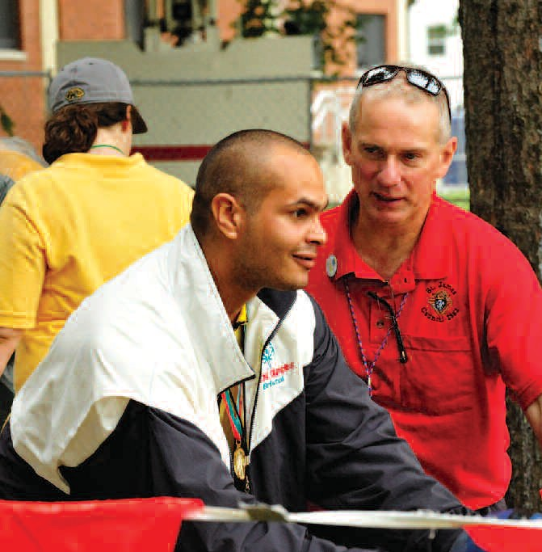
Volunteering Together Project – Special Olympics

One of the most inspiring examples of the Knights of Columbus’ commitment to serving those in need is the service its members and their families provide to people with intellectual disabilities. Beginning with support for the very first Special Olympics games in 1968, efforts in this area have steadily grown.

The Knights of Columbus believes that the Special Olympics are nearly unparalleled in their ability to show the intrinsic worth and dignity of every single human being. These games don’t just build strength and character for the athletes and participants; it only takes a few moments with the competitors to be inspired by the force of their determination and the true sense of God’s love.

Although the Special Olympics have grown in recent years, they still need continued support.

Your family can become involved in assisting Special Olympics in a variety of ways:

  - Work with council and local fundraisers to help collect needed funds to support Special Olympics athletes and programs.

  - Volunteer as a family for Special Olympics. The best way to start is to find the Special Olympics office nearest to you.

  - Share your athletic expertise and passion for sports by getting involved as a coach or official. You can learn more by visiting specialolympics.org.

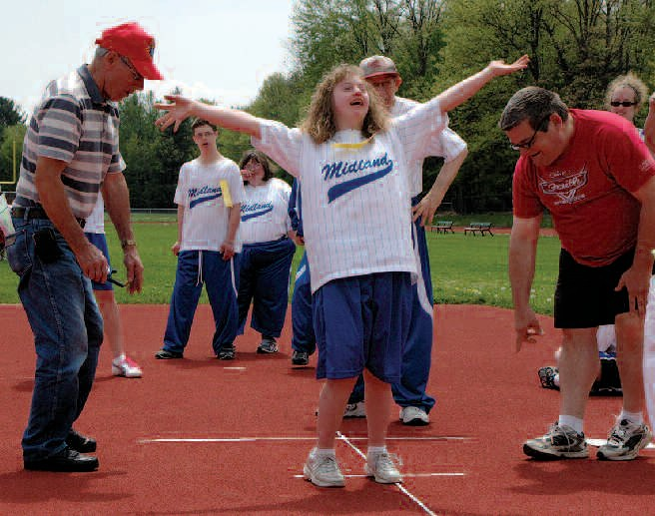
    - If you or someone in your family have specialized training as a health care professional, Special Olympics can use your help in ensuring athletes remain healthy and safe.

    - Along with these volunteer opportunities, Special Olympics also has unique opportunities for high school and college students.

For more information on how to volunteer with Special Olympics, visit specialolympics.org and click the “Get Involved” tab.

19

