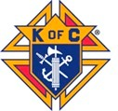Priest & Religious Appreciation Dinner 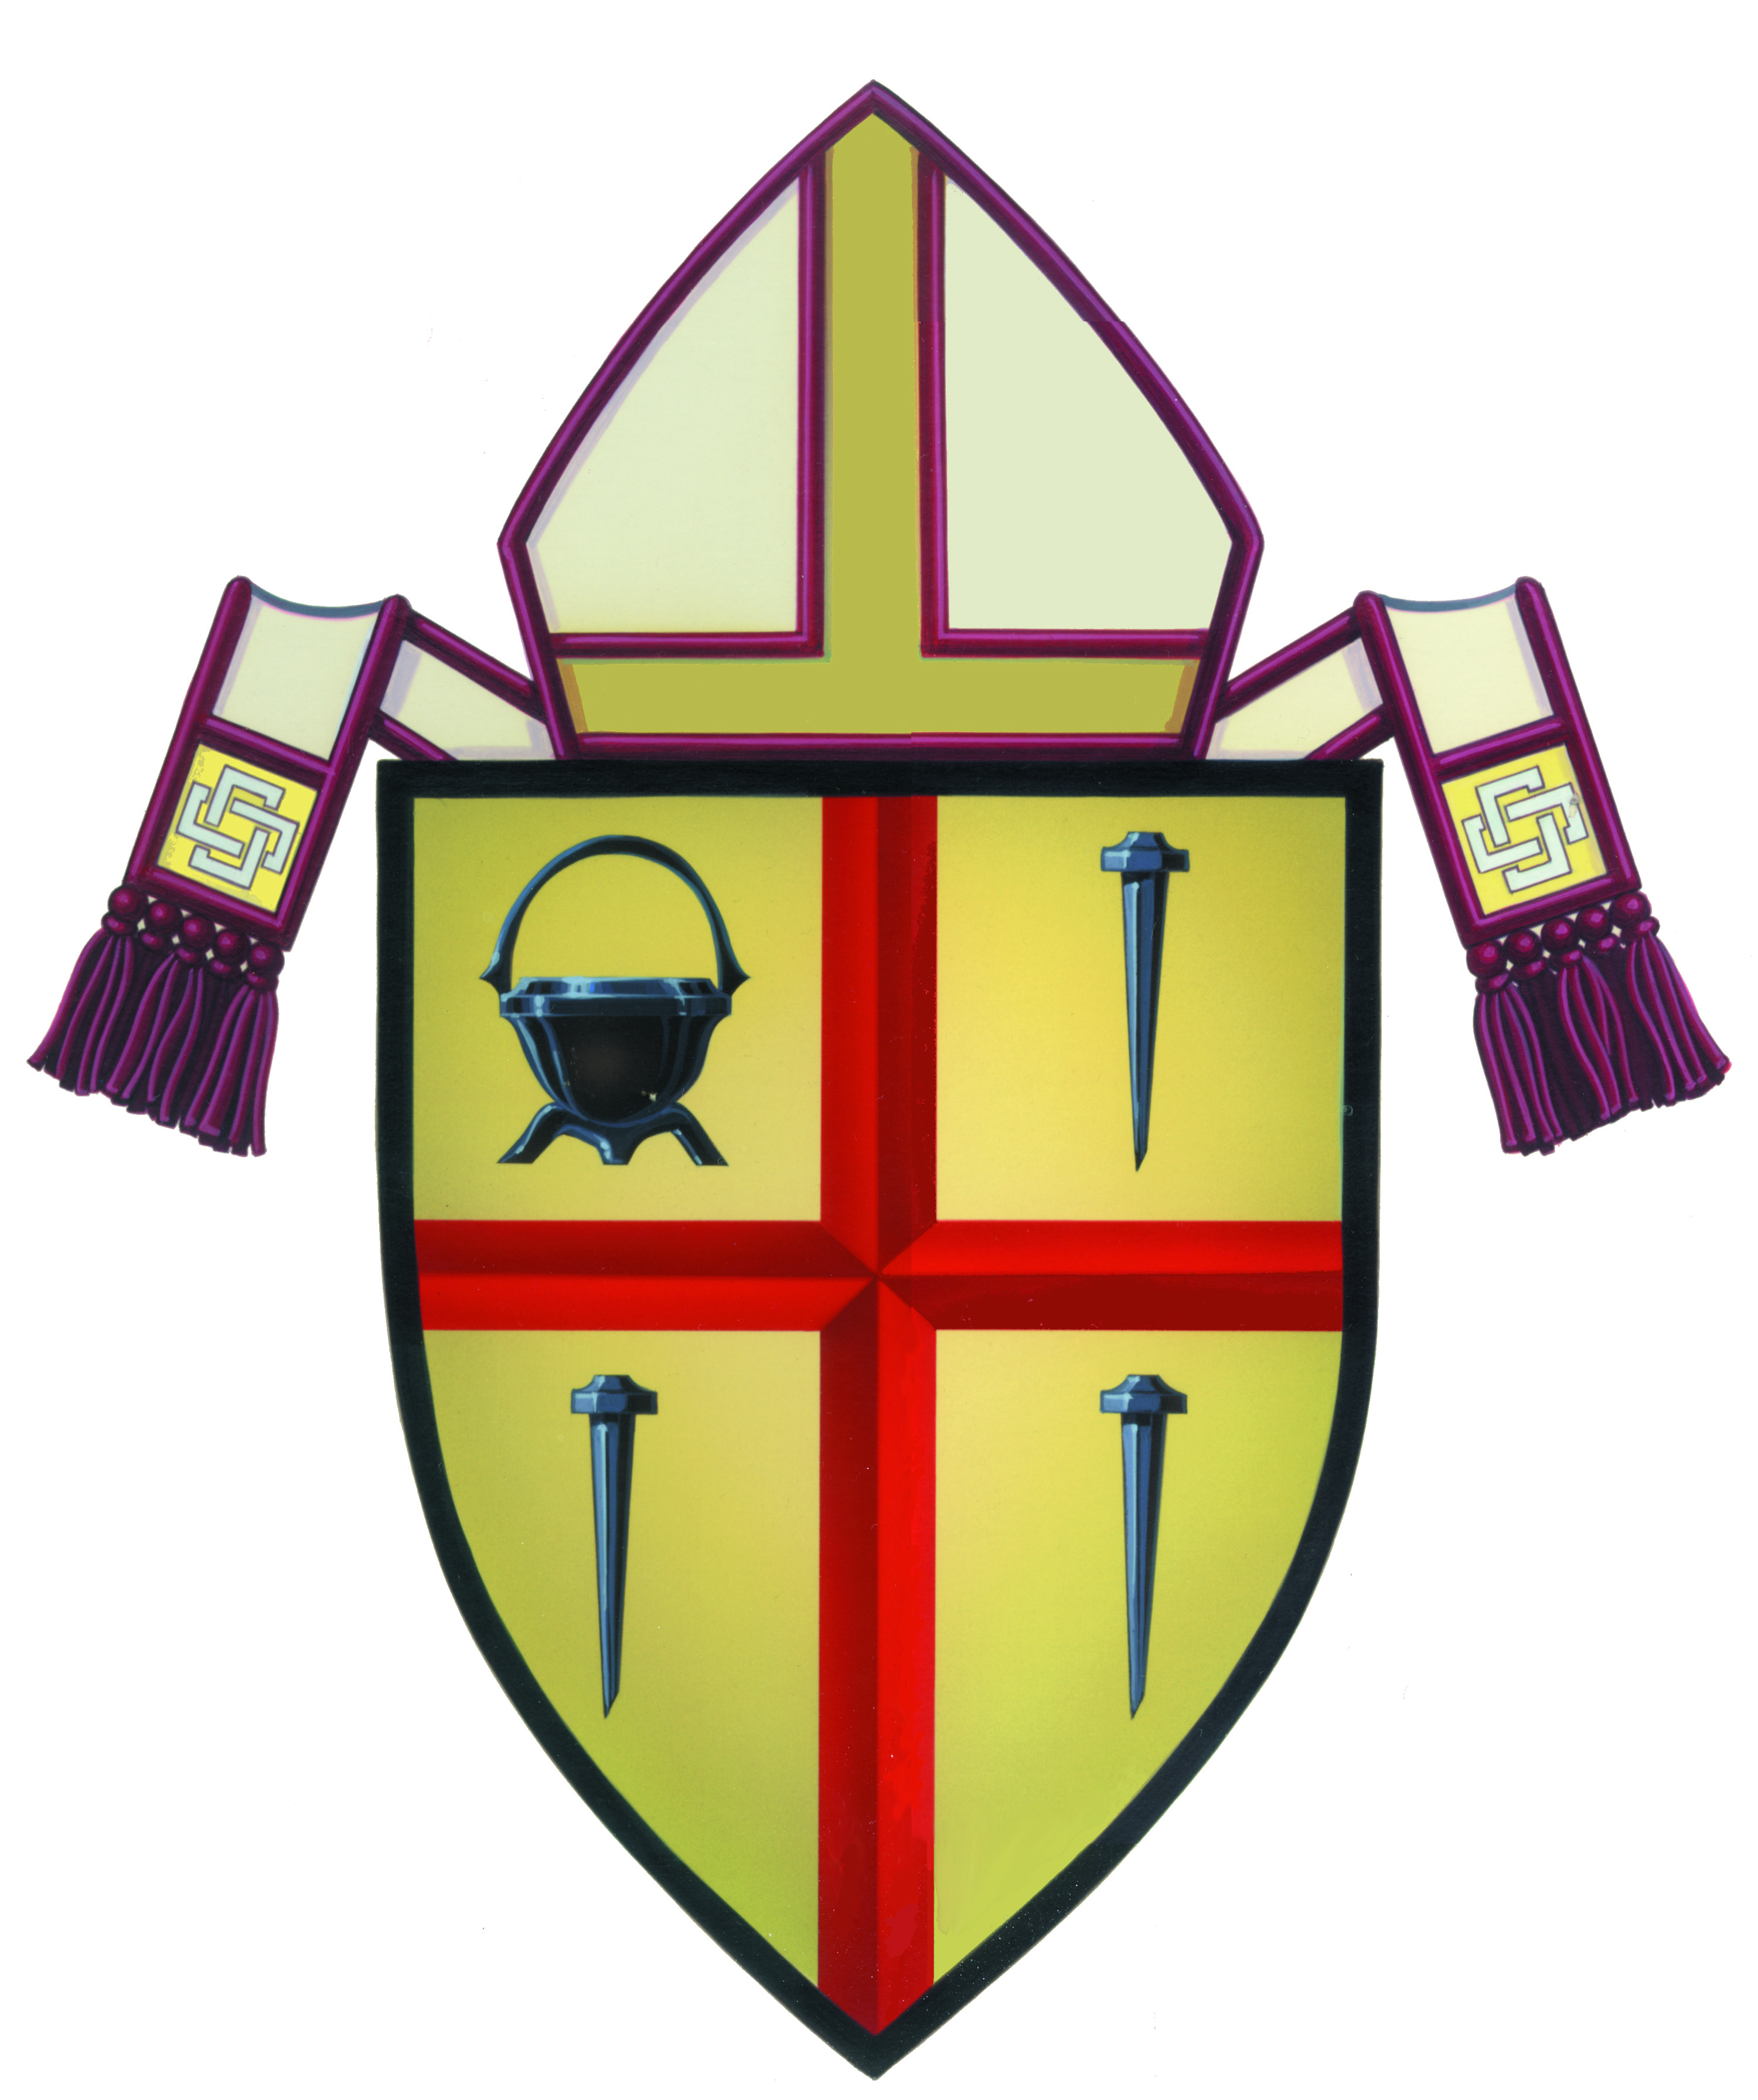
March 10, 2016
St. Michaels Parish Holy Family Center
15546 Pomerado Rd. Poway, CA 92064

Honoring our Priests, Sisters, Brothers, Deacons & Seminarians
Who serve in the San Diego Diocese
6:00 PM Social 7:00 PM Dinner

It is a privilege and honor to invite all of our priests, sisters, brothers, deacons and seminarians in the diocese to an evening of relaxation with Bishop McElroy as our guest of honor and great food.

Priest, Religious, Deacons & Seminarians: Guests of Your Local Council

Knights & All Laity: $35.00 per Person
Table of 8: $250.00

Make checks payable to: San Diego Knights of Columbus
Mail to: John Bertrand, 11333 Creciente Ct. San Diego 92127
RSVP to Brother John Bertrand at sdkofc@san.rr.com or (858) 674-4128
Register on Line at: http://www.sandiegoknightsofcolumbus.com/
Deadline for Reservations is March 5, 2016

