KNIGHTS OF COLUMBUS
“Bishop Cirilo Flores Outstanding Service Award: Boy and Girl Altar Server 2014

Council Number: Parish:
Boy or Girl Altar Server Nomination:

Contact Information of Parents (Name and Phone):

OUTSTANDING SERVER NOMINATION FORM:

Every parish pastor may nominate one altar girl and one altar boy server to receive the San Diego Knights of Columbus Diocese Chapter Bishop Flores Memorial Service Award. This award will be given annually to one girl and one boy altar server who demonstrate outstanding service to their parish as an altar server.

Complete the Nomination Form and return to
Brother Jack O’Rourke by Oct. 25, 2014.
P.O. Box 2697 Ramona, CA 92065
858-395-9985
Winners will be announced at the
Annual Knights of Columbus Priest and Religious Dinner on Nov. 6, 2014.

WRITE A BRIEF SUMMARY WHY, AS PASTOR, YOU ARE NOMINATING THIS ALTAR SERVER FOR OUTSTANDING SERVICE TO YOUR PARISH LAST YEAR: USE A SEPARATE PAGE TO TYPE YOUR NOMINATION IF NEEDED.

$100.00 CASH PRIZE TO EACH WINNER
$50.00 CASH PRIZE TO EACH RUNNER-UP

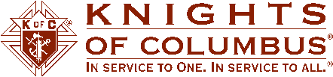

PASTOR SIGNATURE: __________ __________________________ GRAND KNIGHT SIGNATURE ____________________________________ DATE __________

